**Setting up firing Input**

1. Open **PlayerController.cs**
2. Call a **ProcessFiring** method in Update method and create the definition after the **ProcessRotation** method.
3. Type some pseudocode for the overall goal for this method

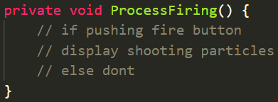

1. Go to Project Settings> Input Manager and look for Fire1

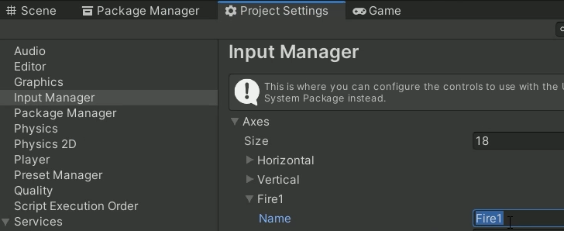

1. Inside of **ProcessFiring** write this code

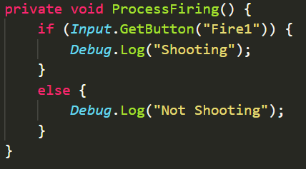

1. Go to Unity and test it out. If you left click the mouse it should show up as firing.